

*Certificate of Enrollment*

**CERTIFICATE OF ENROLLMENT**

as a partner in the DoNation Campaign to improve awareness about organ donation and increase organ, eye, and tissue donor registrations.

AWARDED TO

DATE

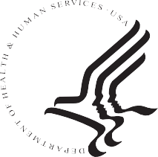U.S. Department of Health and Human Services Health Resources and Services Admministration

Division of Transplantation Health Systems Bureau