ITD Project Management Database

The initial screen of the ITD Project Management Database presents you with five options. To view any of these options, simply click on any of the links.

* **Submit a New Project Proposal**
* **View | Edit Project Proposal**
* **View | Edit Projects**
* **View | Edit Resources**
* **Rank Projects**

**Submit a New Project Proposal**

* This option is the initial starting point for any new project. On this screen your must fill out all fields that are shaded in yellow.

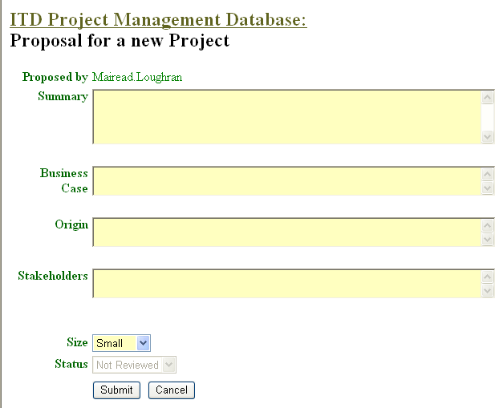

* Your name will always appear beside “Proposed by”.
* Once you have entered all information then click **Submit**. The project proposal is then sent to the relevant individual for approval. You will not be permitted to submit a Project Proposal without filling in these fields.
* To return to the previous screen without submitting information, simply click on the

**ITD Project Management Database** link at the top of the window.

# View | Edit Project Proposal

* This page displays all projects that have been submitted for approval. The projects are divided according to whether they

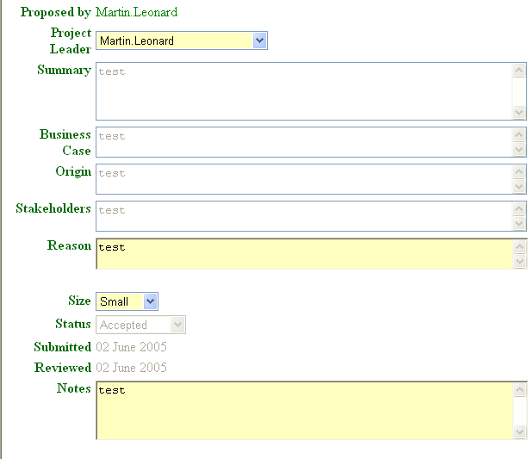

have been **Not Reviewed, Accepted or Rejected.** Move between these three options to find your project.

* To view details of your project click on

**Select** to the right of the project.

* You will not be permitted to change any information entered in the project proposal stage. However, you must enter information into the yellow shaded fields as these are mandatory.

# View | Edit Projects

* This page displays all projects; again they are divided into different categories. Click on the drop-down arrow beside **View.**
* To view a project, choose Select. This page will display information entered at an earlier stage but you cannot make changes to it.
* However, at this stage you can add the team members and the various milestones of the project.

# View | Edit Resources

This page allow you to view and add in new resources such as people. Simple enter the information under **Describe** and choose the type of **Resource** from the drop-down list and then choose **Add.**

# Rank Projects.

This page permits the ranking (priority) of projects.

* Small projects are ranked by the team leader’s manager
* Medium projects by the ITD Management team
* Large projects by the IT steering Comittee

Find the project and choose **Increase** or **Reduce** to adjust the priority of the project.