

|  |  |  |
| --- | --- | --- |
| SWOT  Manual | AY13 | |
| (Strengths, Weaknesses, Opportunities, & Threats) | |  |

**Contents**

**What is a SWOT? 3**

**Benefits of a SWOT Analysis 3**

**SWOT Materials 4**

**How is the SWOT conducted? 5**

**Proposed List of areas should be covered 6**

**What’s NEXT? 7**

**ACC SWOT Procedures/ Processes and Scheduling 8**

SWOT MANUAL (download pdf)

**What is a SWOT?**

A SWOT analysis is a planning tool that, when used properly, provides an overall view of the most important factors influencing the future of the program. The SWOT analysis is the foundation for a reflective self-assessment of how your unit is performing its mission. The SWOT analysis results form the basis for developing recommendations and action plans, also known as Quality Improvement Plans (QIPs). These recommendations and action plans take into consideration many different internal and external factors that maximize the potential of the program’s strengths and opportunities, while minimizing the impact of its weaknesses and threats. This approach can help ensure efficient use of resources to provide beneficial program outcomes. A SWOT analysis enables proactive thinking rather than habitual or instinctive reactions

A SWOT analysis is one of several tools for assessment and planning at Austin Community College. This manual is meant to help understand the general SWOT analysis process, as well as provide detailed guidance for a organizing and conducting a SWOT analysis.

* Units are required to conduct an intensive self -review on a 5-year rotating schedule. The Instructional Program Review (IPR) and the Support Services Review (SSR) both follow the same general process.
* During an intensive review year, units participate in a facilitated SWOT analysis to determine what their strengths and weaknesses are and how the environment will affect their ability to accomplish their mission

**Benefits of a SWOT Analysis**

A SWOT analysis is a simple, but powerful, framework for leveraging the unit’s strengths, improving weaknesses, minimizing threats, and taking the greatest possible advantage of opportunities.

**SWOT analyses have several benefits**

* Opportunity for collaboration on strategic plan formulation.
* Incorporates many different internal and external factors.
* Structured process that allows for a thorough idea gathering.
* The posting of the ideas vs. the yelling minimizes the reactionary processing and group mentality from occurring.
* Participants who may traditionally be quiet and participate less, are encouraged, and have the ability to participate in a process which is friendlier to their needs.
* Allows the ability for “dominators” (*overly* vocal participants) of the process to be equalized -- but not eliminated.
* Responses are prioritized within each category, by importance, giving units a clearer understanding of their most pertinent topics and areas to address.

**How are the Results of a SWOT Analysis Used?**

A SWOT analysis is a subjective assessment of data that is organized into a four- dimensional SWOT matrix, similar to a basic two-heading list of pros and cons.

|  |  |  |
| --- | --- | --- |
|  | **Strengths**   * what the unit does very well   *internally* | **Weaknesses**  where functions are performed  *internally* less than preferred |
| **Opportunities** potentially favorable *external* conditions for the unit | S&O: Pursue opportunities that are a good fit with the program’s strengths. | W-O: Overcome weaknesses to pursue opportunities |
| **Threats** potentially unfavorable *external* conditions for  the unit | S-T: Identify ways the program can use its strengths to reduce its vulnerability to external threats. | W-T: Establish a defensive plan to prevent the program’s weaknesses from making it highly susceptible to external threats. |

To develop initiatives (strategies) that take into account the SWOT profile, unit members can translate the four lists into a matrix (see above) that associates strengths (maintain, build and leverage), opportunities (prioritize and optimize), weaknesses (remedy), and threats (counter) into actions that can be agreed and owned by the unit.

**SWOT Materials**

The facilitator is responsible for providing the following materials for the SWOT session. If you are going to conduct (facilitate) a SWOT session *yourself*, you will be responsible for providing these materials.

* Post-Its – LARGE (*multi-colored, minimum of 4 colors, “super-sticky note”)*
* Alternative style sticky note for labeling groups
* Name tags (*optional*)
* Black markers (*no fine point, need to read at distance*)
* Paperclips or binding clips
* Masking tape
* Multi-colored sticker dots (*med size*)

**How is the SWOT conducted?**

**Identification of Strengths, Weaknesses, Opportunities and Threats. (SWOT)**

* The facilitator should introduce the group and set some ground rules/ guidelines.
* The facilitator should lead a discussion about the unit/program’s data and how they relate to the unit/program’s performance of its mission. This will help illuminate existing strengths and weaknesses. The strengths and weaknesses should help identify possible opportunities and threats.
* After the discussion of the data, the facilitator will walk the participants through the process of brainstorming about each of the SWOT elements, one at a time (e.g. Strengths first, then Weaknesses, then Opportunities, then Threats). Participants will be asked to relate their thoughts or comments to the data and write them down on the Post Its.

**NOTE**: While conducting the session**, e*ncourage participants to use phrases that are clearly understood***

when writing out suggestions or comments for posting.

* Clarify SWOT statements during the session to ensure “context” of statement in future discussions and analyses.
  + Strengths – ***in what ways does the unit/program excel?***

## Weaknesses – what aspects of the unit/program, which, if not addressed, will impede the area's future?

* + Opportunities – ***what factors, which the unit/program needs to take advantage of that, might enhance the quality of the area.***

## Threats – what external factors could negatively affect the unit/program’s future?

**SWOT Process:**

* + The facilitator should circle the room continuously collecting the post-its.
  + The notes should be placed in a random pattern across the front of the group minimizing and ensuring that they are not “clumped” with or by any bias.
  + When the group seems to have finished with writing topics, the facilitator should then proceed to read aloud the entire list on the wall.
  + Next, the SWOT participants are encouraged to come up and “group” the topics into “themes” or likenesses.
  + The facilitator will next work with the participants to collectively come to an agreement and agree on a “title” for each of clusters...
  + There may be a massaging of the groupings upon the themes that are brought out.
  + After the groups are titled, the facilitator re-reads the clusters to ensure that the consensus is that all topics fit under that them.
  + Next, the facilitator hands out to the participants an apportioned set of sticker dots.
  + The participants use the dots for ranking.
  + The participants can use them to rank either the group themes or individual topics within the cluster.
  + The facilitator then collects and stacks the clusters, ensuring to stack so that report writing can be one easily.
  + Upon completion of the STRENGTHS portion, the facilitator may encourage a brief break or move onto the next section.

**NOTE**: *Once all statements have been reviewed on the board, for the purpose of more efficient and accurate processing/ reporting, the facilitator is asked to stack the Post-its according to the identified categories. This will allow the person creating the SWOT report to quickly (and more reliably) input the data.*

**NOTE**: *There may be a need for the facilitator to keep the focus of the group on task*. *The group may start to wander off topic and into another area of the SWOT process.*

**Proposed List of areas should be covered:**

1. NEED – Is the need for the program/unit increasing, decreasing, staying the same?
2. COST –
   1. Are program/unit costs increasing, decreasing, staying the same?
   2. In what areas is our budget adequate/inadequate?
3. PROGRAM/UNIT EFFECTIVENESS – Questions for program/unit effectiveness will vary, depending up the area or program/unit being addressed. Although this list is not comprehensive, some ***examples*** are listed below:

*Some of the following areas will be specifically applicable to instructional programs and some to administrative units. Some areas will be applicable to both. Choose areas that are relevant and/or correlate to your program/unit’s data.*

*Student Achievement*

Are graduation/transfer rates a concern?

*Student Retention*

Are course completion rates higher/lower than average?

*Student Outcomes*

How do students do at transfer institutions? How do students do on the job?

What other kinds of outcomes are important to us?

*Access*

*Curriculum*

*Instruction*

*Technology*

Is the gender/ethnicity of our students a concern?

Can students take courses at different times/places/methods?

Are we offering enough/too many/about the right number of sections/services? Can student get timely services? Possible barriers?

Is curriculum current and reflective of our field?

What are changes that we see coming in our discipline? Is the curriculum aligned with UT/SWT and others?

Is the curriculum articulated with UT/SWT and others?

How are we accommodating educational theory in the ways we teach? How will changes in delivery of instruction affect our area?

How are we accommodating technology in the ways we teach? How will changes in technology affect our area?

Are we using technology sufficiently in providing service?

How can we improve or maximize our technological resources for better effectiveness?

*Faculty/ Staff Development*

In what areas are our faculty/staff strong?

Where do we need to focus faculty/staff development?

*Diversity*

Is diversity of faculty/staff strong? Is diversity of students strong?

*Student Satisfaction*

What do we know about how our students feel regarding our courses/ services?

*Transfer*

What do we know about how transfer institutions regard our courses/students? Are transfer institutions making any changes that will affect us?

*Delivery of Services*

Are we delivering timely service?

Are we providing quality service to our students and stakeholders?

**What’s NEXT?**

The SWOT analysis should result in a list of the issues that are the most pertinent for the program/unit area at this time. These will form the basis for any QIP (*Quality Improvement Plan*).

At the end of the SWOT analysis, the facilitator will collect and stack the Post-its in respective groupings and either

* return them to the OIEA office for processing

OR

* the facilitator may wish to use the SWOT report and enter the data themselves.

If returned to OIEA, the staff will enter the SWOT details into the SWOT report and email to the primary contact person and the SWOT facilitator.

**ACC SWOT Procedures/ Processes and Scheduling**

**As part of the overall review of the program or unit, it is required that the following actions be taken prior to conducting the program’s/ unit’s SWOT session. This will help maximize the benefits of the SWOT session and analysis.**

***Data must be used as part of the SWOT session and analysis***

1. Collect and review data to be used in SWOT discussion.

# Prior to SWOT session – To allow time to review data, it is recommended that the data be provided to participants AND facilitator no later than 2-3 weeks prior to the SWOT session.

* + - ***IPR*** data should consist of student success and performance indicators
      * Data can be obtained through TIPS (The Information Portal System), or through the [Data Request Form](http://fs11.formsite.com/soon/OIEADataRequestForm/index.html)
      * Examples of data include:
        + Enrollments Trends
        + Successful Course Completions
        + Departmental Snapshots
        + Cohort Data
        + Heatmaps / Survival Charts
    - ***SSR*** data should be identified and related to the unit’s mission and purpose
      * The unit’s mission statement or purpose should be used as a basis/guide for selecting the appropriate data to review.
      * Examples of data could include:
        + Point-of-Service Surveys
        + Departmental Performance Metrics
        + CAS Standards Metrics
        + Scheduling Data
        + Time Served Data
        + Benchmark Data

**The self-study chair/ unit review leader is responsible for scheduling and inviting the participants to the SWOT program.**

# Items to check BEFORE scheduling

* + Check swot calendar for available [SWOT slots](https://www.google.com/calendar/b/0/selfsched?sstoken=UUpOR1ZSOS1LYi1rfGRlZmF1bHR8YTA3YjExNWQ5NjA0MzNkMTJjMDdjMjI4YWM0NjE5MGQ) (opens in Google calendar)
  + Check attendee/ invitee calendars for availability
    - *Internal personnel* – involved in the division/ unit/ program
    - *External personnel* – students and people from the unit/ program areas that interact with the department/ unit/ program regularly, advisory groups.
* The reason for this is to make blinds spots and distortions in SWOT evaluations less likely, due to the variety of experiences, interests, and opinions represented.
* Check rooms for availability ([R25 site](http://r25prod01.acc.austincc.edu/wv3/wv3_servlet/urd/run/wv_event.DayList?evdt=20111114%2Cevfilter%3D88624%2Cebdviewmode%3Dlist))

*SWOT sessions are between 3 and 4 hours long.*

1. Scheduling the SWOT

[OIEA SWOT FACILIATOR Google CALENDAR](https://www.google.com/calendar/selfsched?sstoken=UUpOR1ZSOS1LYi1rfGRlZmF1bHR8YTA3YjExNWQ5NjA0MzNkMTJjMDdjMjI4YWM0NjE5MGQ)

* + Signing up for an appointment slot:

i. When you visit our sign up page, your primary ACC calendar is overlaid for convenience and you can sign up directly for any available appointment slot.

# NOTE: Appointment Slots Can NOT have the date/ time adjusted by either the facilitator or the requestor. If you must change meeting you MUST select another appointment slot.

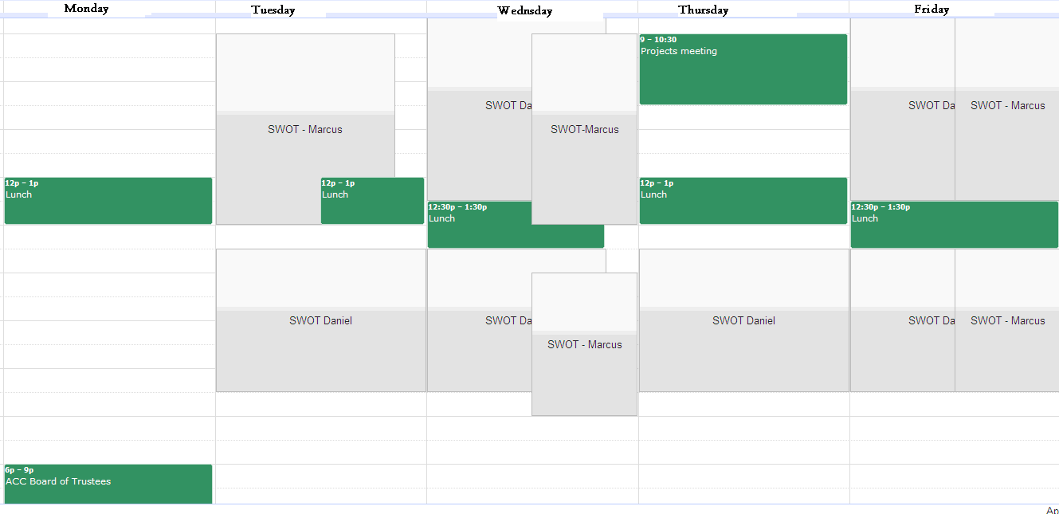

* + When you sign up, Google Calendar conveniently creates a new-shared event on both of the facilitator and requestors calendars. This is where you will be updating Room/ inviting attendees/ etc.
* Reserve location for SWOT session. [R25 site](http://r25prod01.acc.austincc.edu/wv3/wv3_servlet/urd/run/wv_event.DayList?evdt=20111114%2Cevfilter%3D88624%2Cebdviewmode%3Dlist)

(OIEA does not reserve rooms)

1. Invite participants to create a broad range of stakeholders.
2. Provide water/ beverages/ snacks. This is optional, *but recommended*, as the SWOT session is scheduled for 3 hours or more. (**Not provided by OIEA; Follow administrative rules)**

4.